**Constructor**

Constructor job is to initialize the object not creating the object.

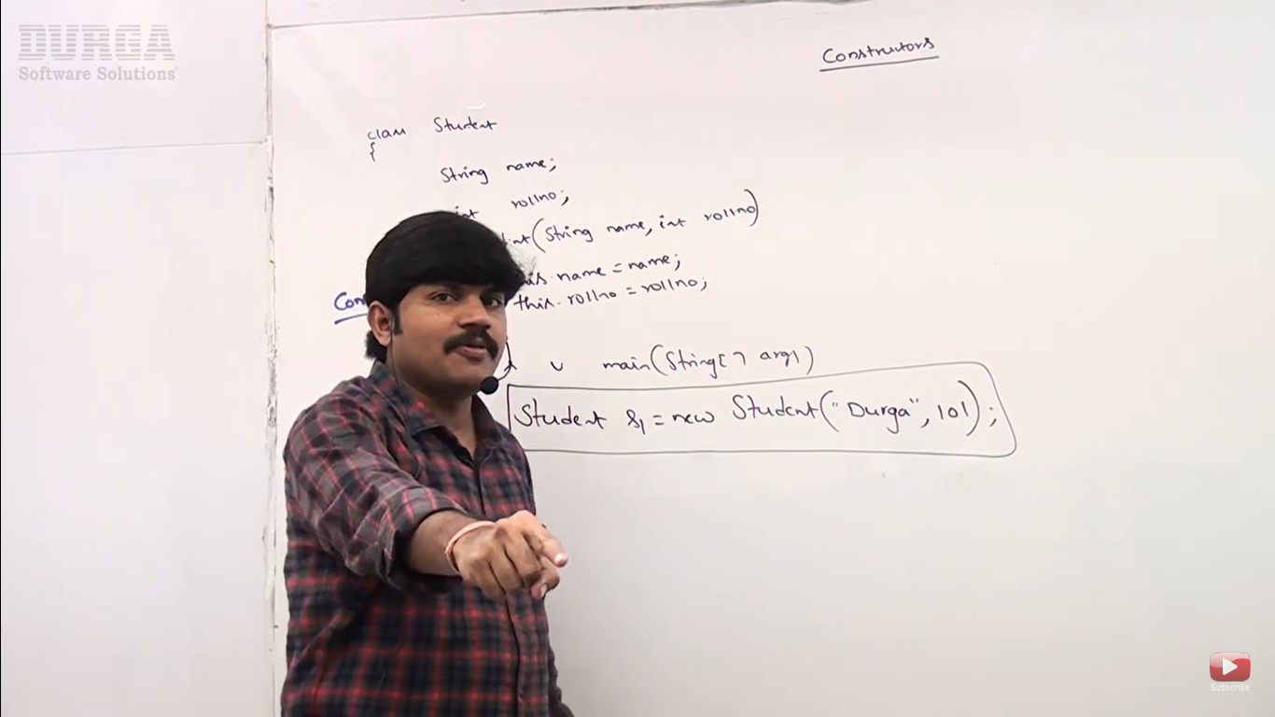

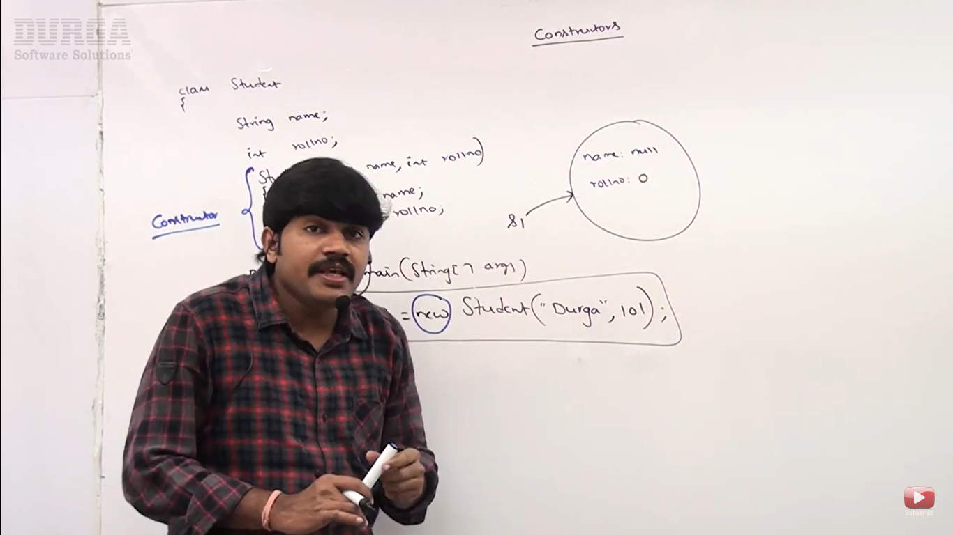

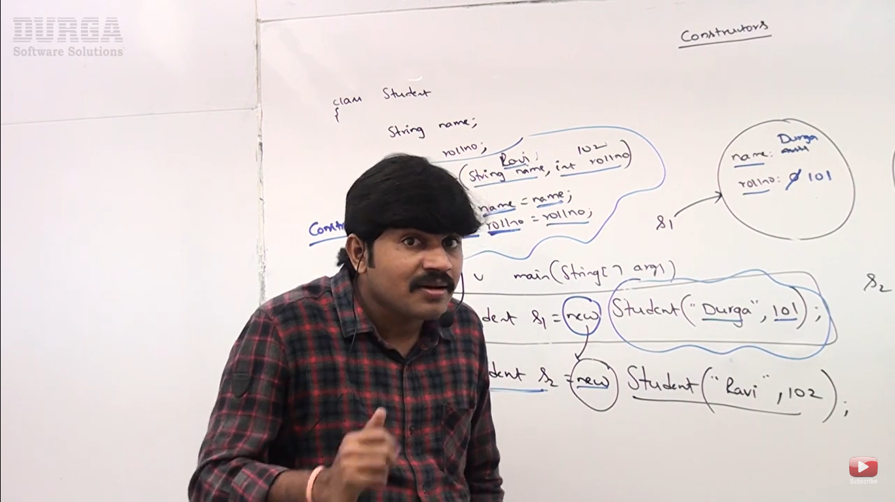

Sample constructor program

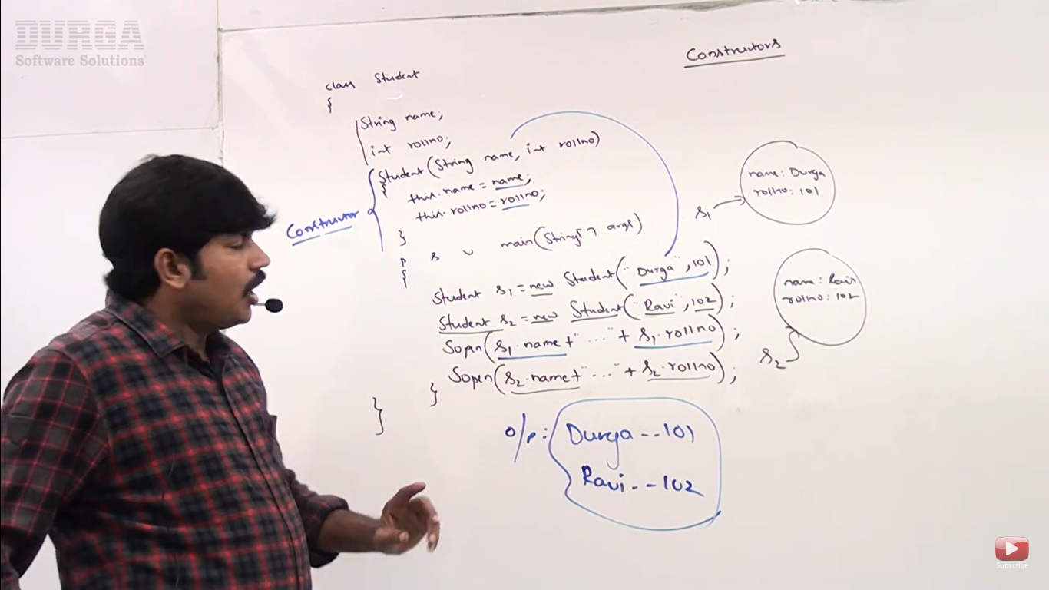

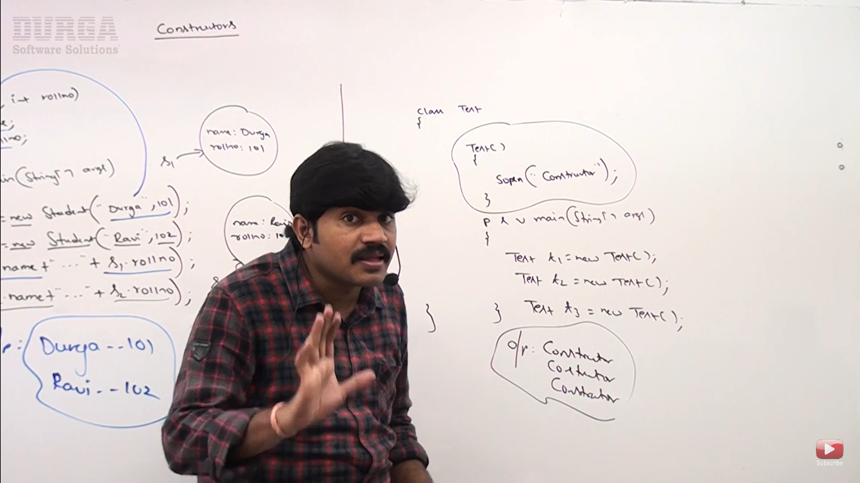

**Rules For Constructor**

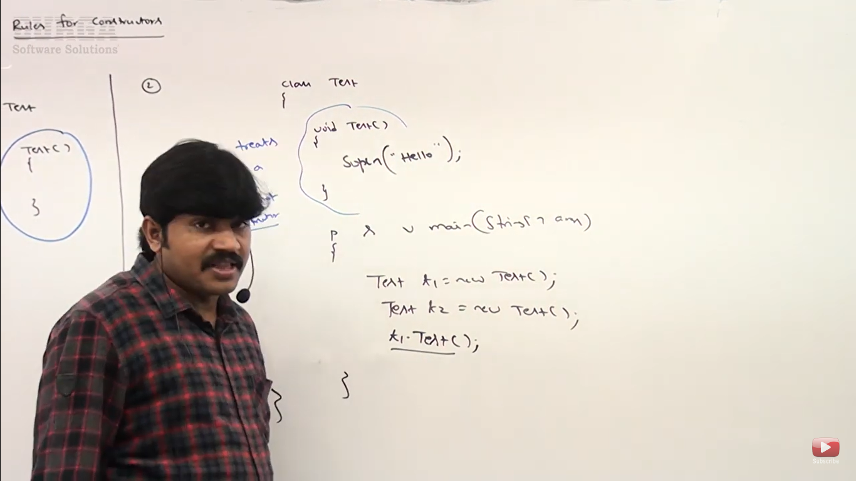

We can’t specify return type with constructor it will be treated as method.

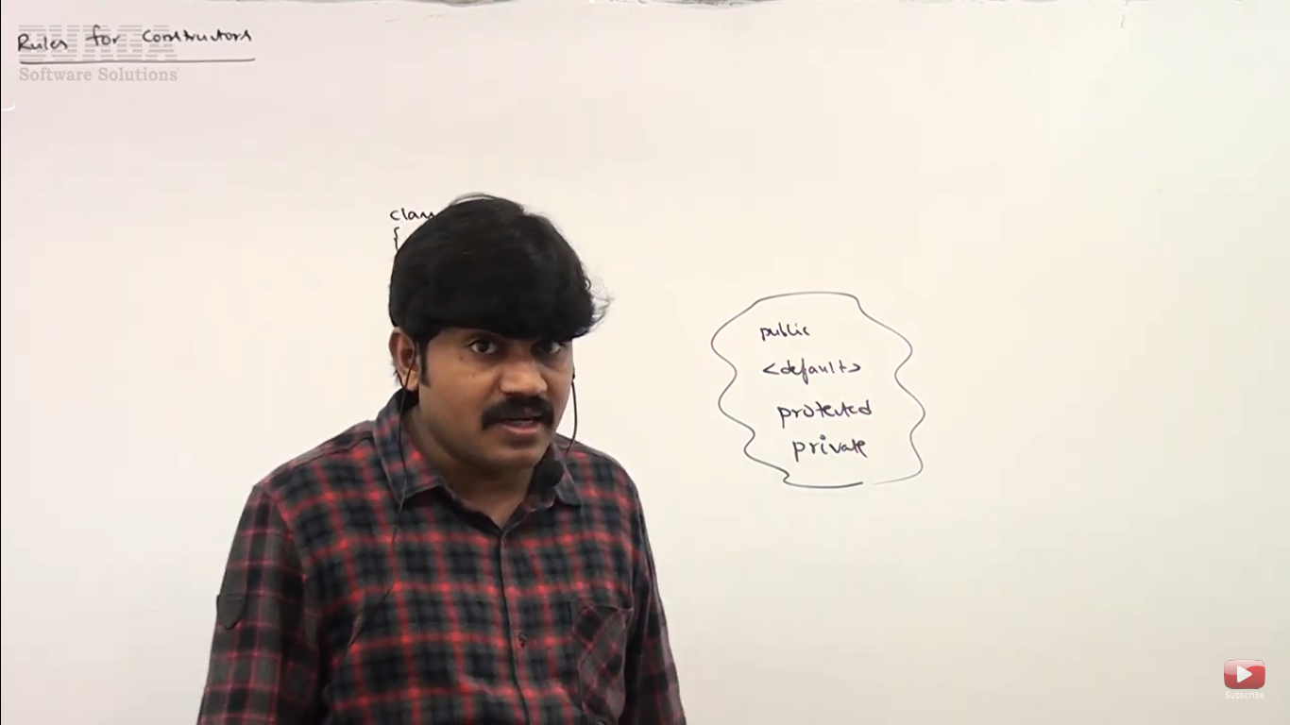

Access modifier applicable for constructors:

Public

Private

Protected

Default

Every class in java including abstract class contains constructor. Default constructor is called if we don’t specify constructor. If we specify parametrized constructor then by default, default constructor will not be called.

**Default Constructor**

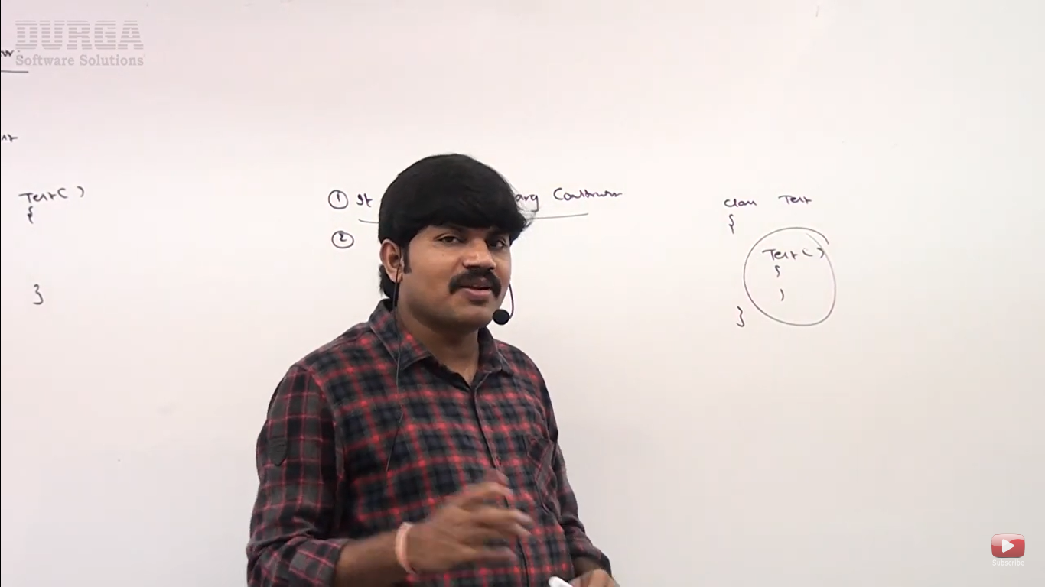

1. Default constructor is no-arg constructor
2. Access modifier of default constructor is always same as class modifier. If the class is public default constructor is also public if class is default then constructor is also default

For [public,<default>]

1. Default constructor only contains one line which is super(); it is a non-argument class.

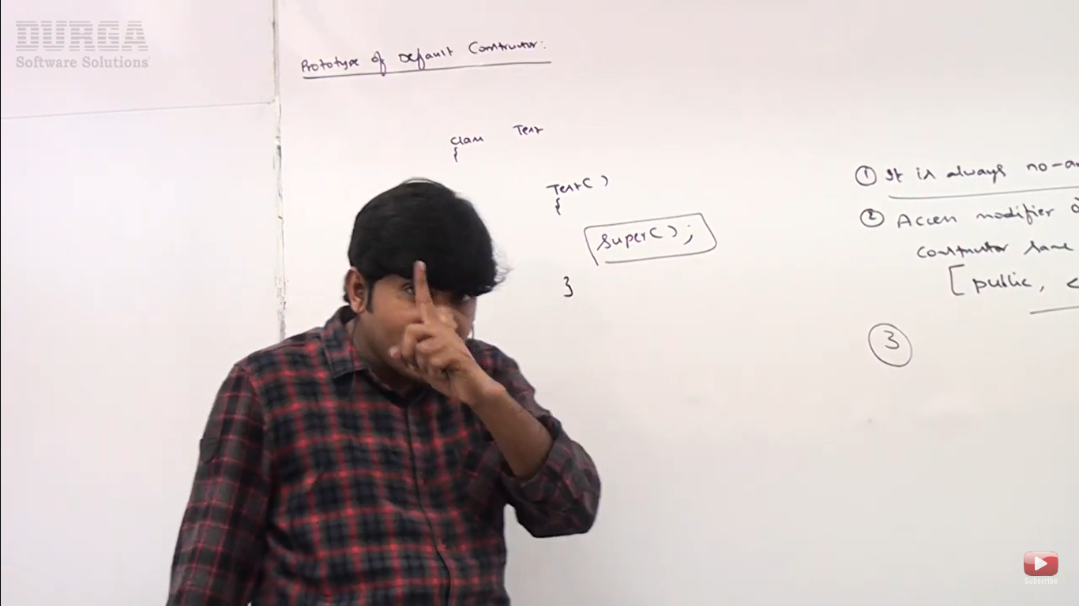

**Note - Yes, in Java, a class can be declared as final. When a class is marked as final, it cannot be extended or subclassed by any other class. This is useful in various scenarios where you want to prevent inheritance to preserve the integrity of the class's implementation**

In Java, the access modifier for the default constructor of a final class is determined by the class's access level. The default constructor is the constructor that the Java compiler provides automatically if no other constructors are explicitly defined in the class. The access level of this default constructor is the same as the class's access level.

**Access Modifiers for the Default Constructor:**

1. **Public Class:**
   * If the final class is declared as public, the default constructor is also public.

**Note -** • **protected:** The protected access modifier is meant for members (fields, methods, and constructors) of a class, allowing them to be accessible within their own package and by subclasses (even if those subclasses are in different packages). Applying protected to a class itself doesn't make sense because classes aren't inherited in a way that would make protected relevant to their accessibility.

• **private:** Making a top-level class private would render it inaccessible from any other class, even within the same package, which would make it effectively unusable. Hence, the language designers didn't allow this for top-level classes

**Case 1: Call to super() must be first statement**

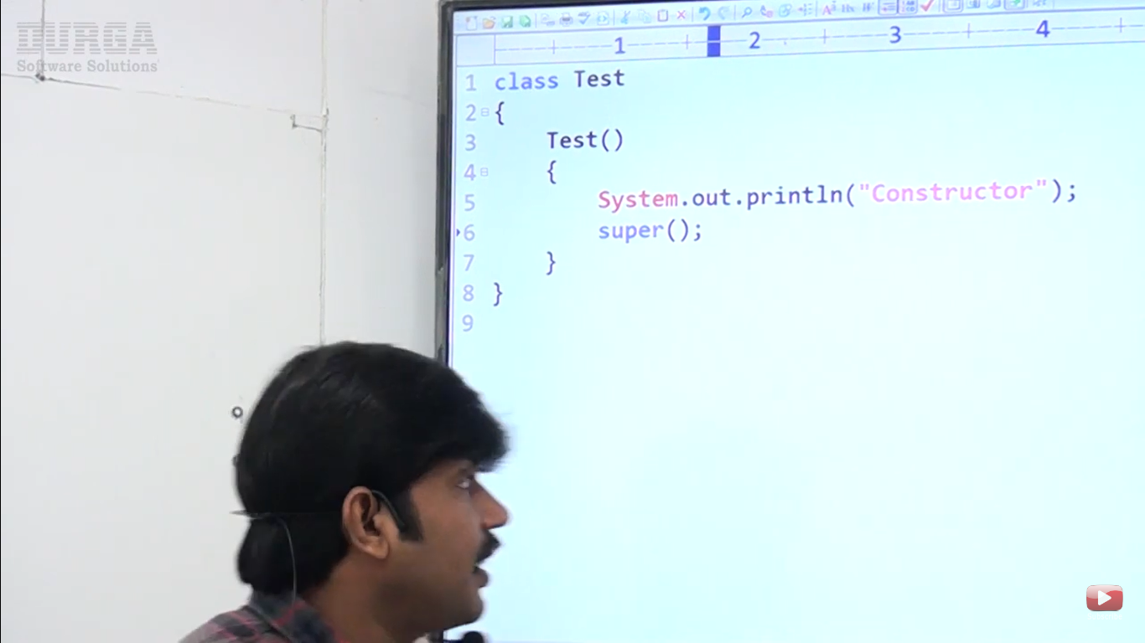

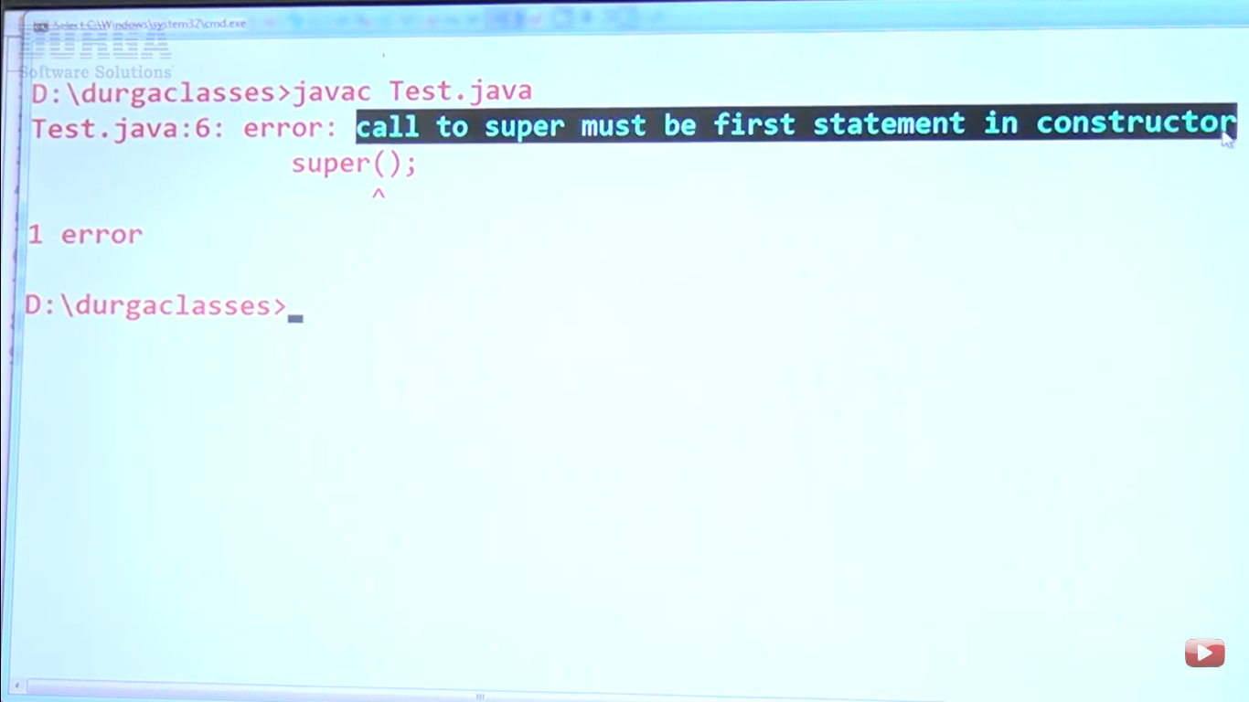

**Case 2: Can we use super() and this() keyword in constructor**

**We can use super() or this() but not simultaneously**

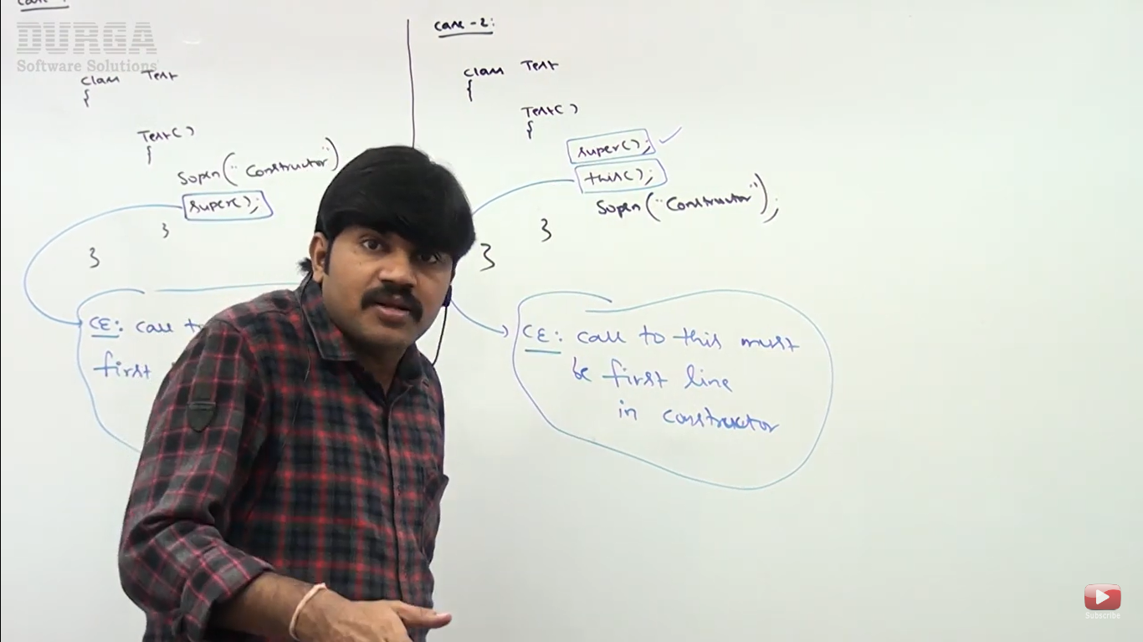

**Case 3: Can w euse super() keyword in method – No we cannot use in method, we can use super() and this() only in constructor**

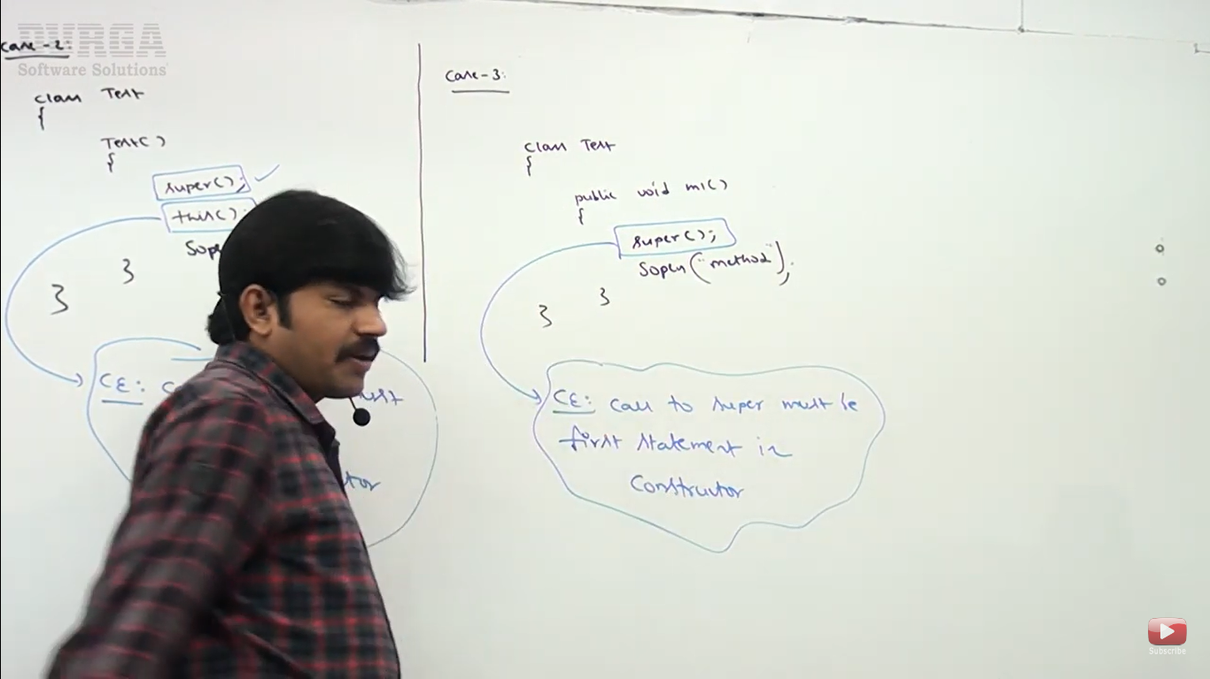

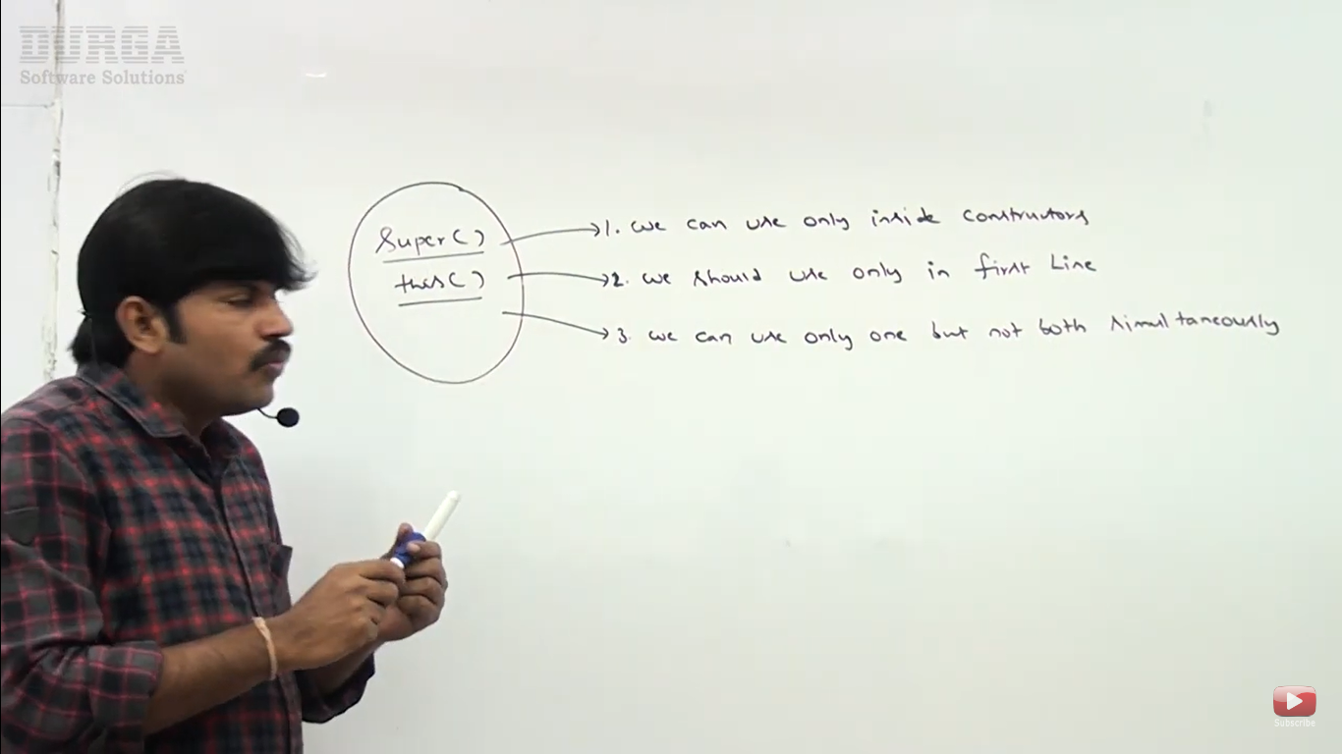

**Difference between super(), this() and super, this**

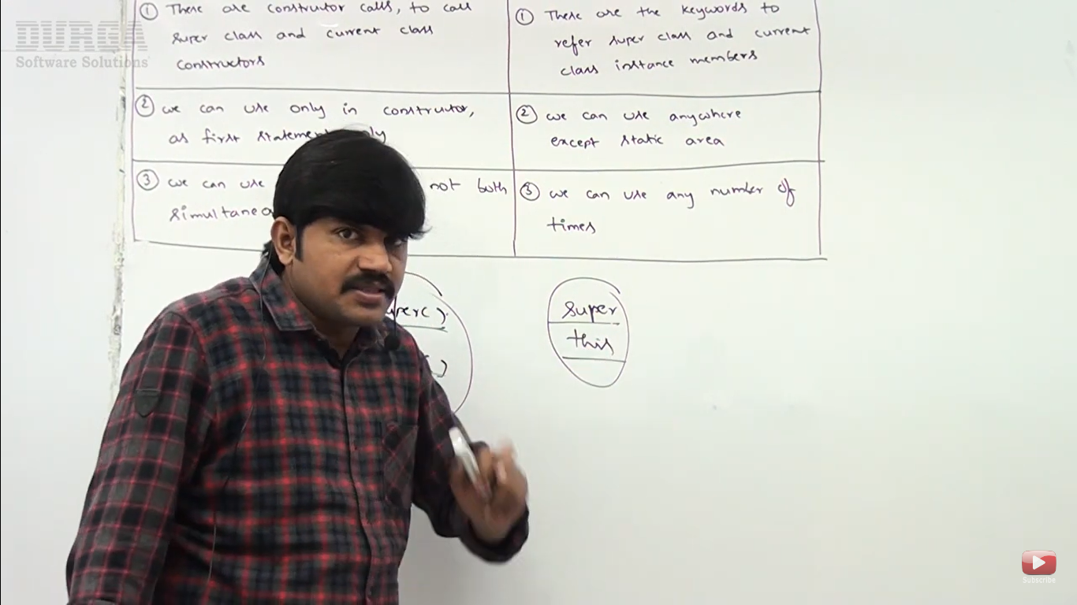

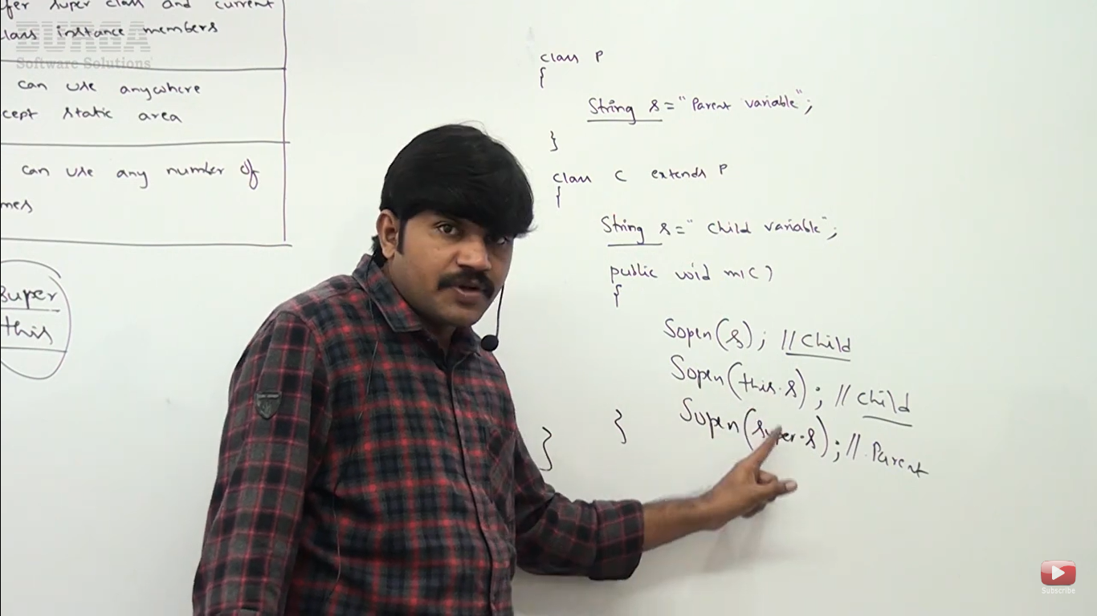

**Note – we can’t use super and this keyword any where except static area.**

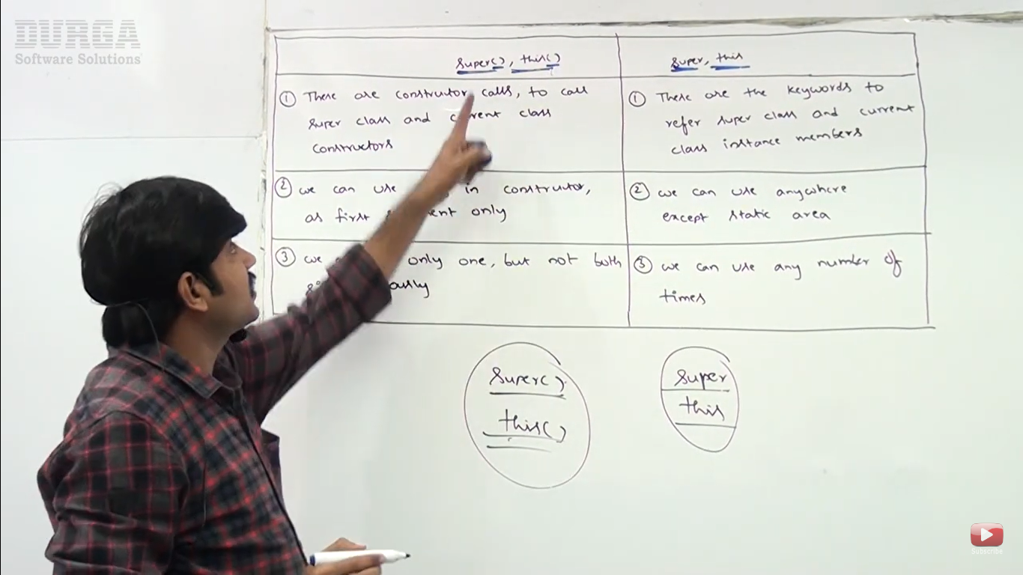

**Super and this keywords are always related to object so we can’t use static area.**

**Constructor Overloading**

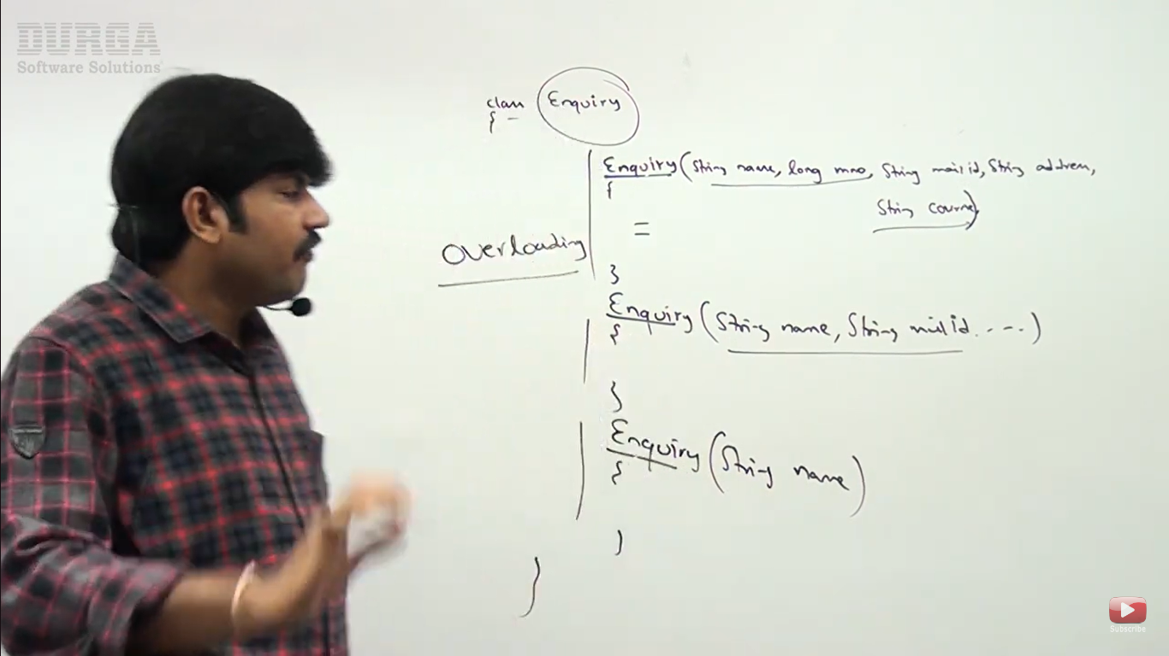

**Constructor chaining**

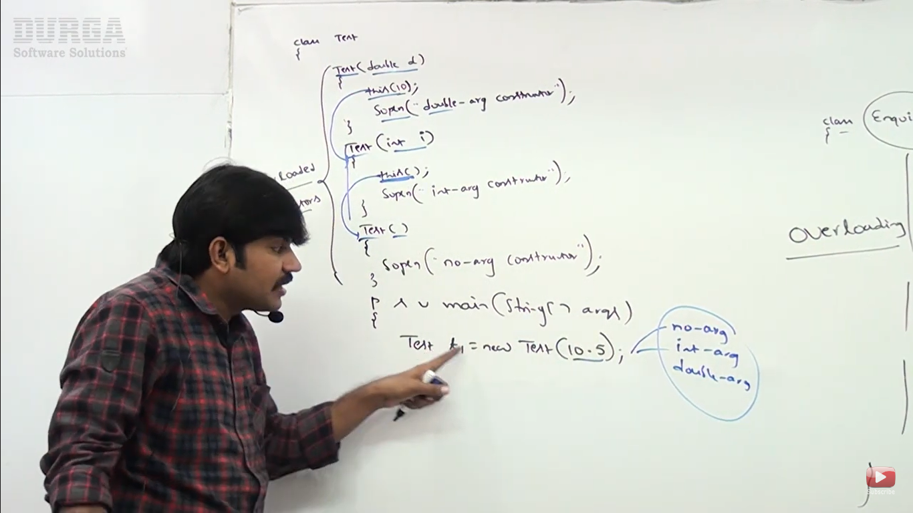

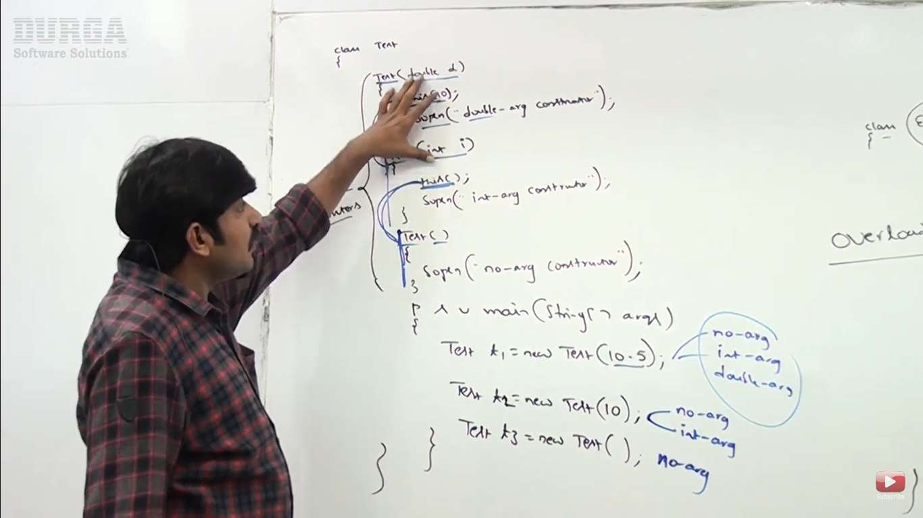

**A class can’t contains multiple constructor but with different parameter or no parameter or different parameter type.**

**Constructor Inheritance and Overriding**

Constructor inheritance and overriding concept not applicable for constructors.

Ineritance concept

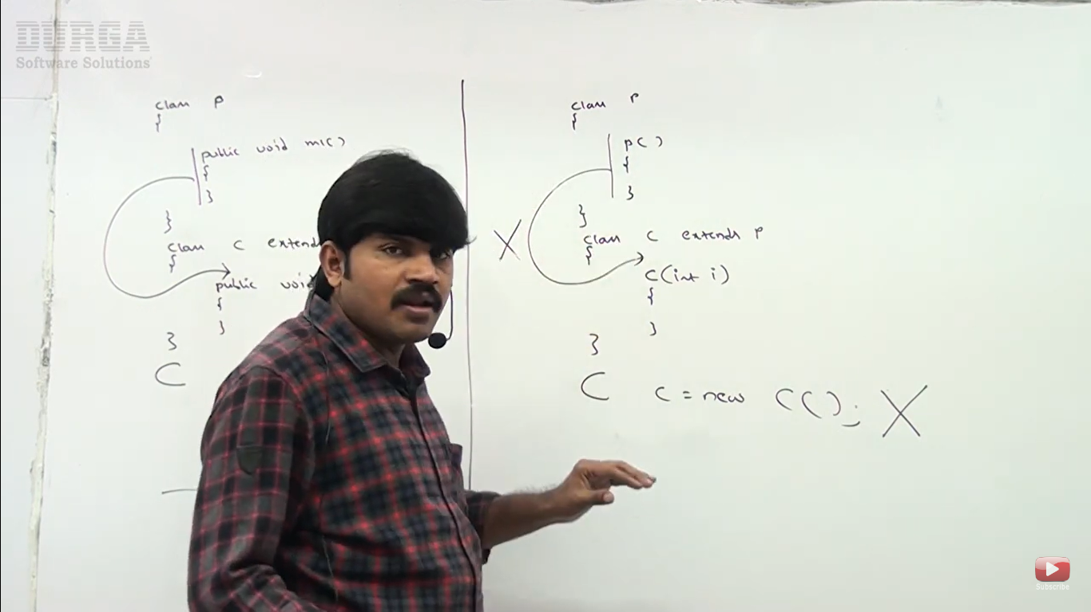

Parent constructor is not available to child

To perform initialization for instance variable in class we require constructor but in interface all variable are public static final so constructor is not applicable to interface.

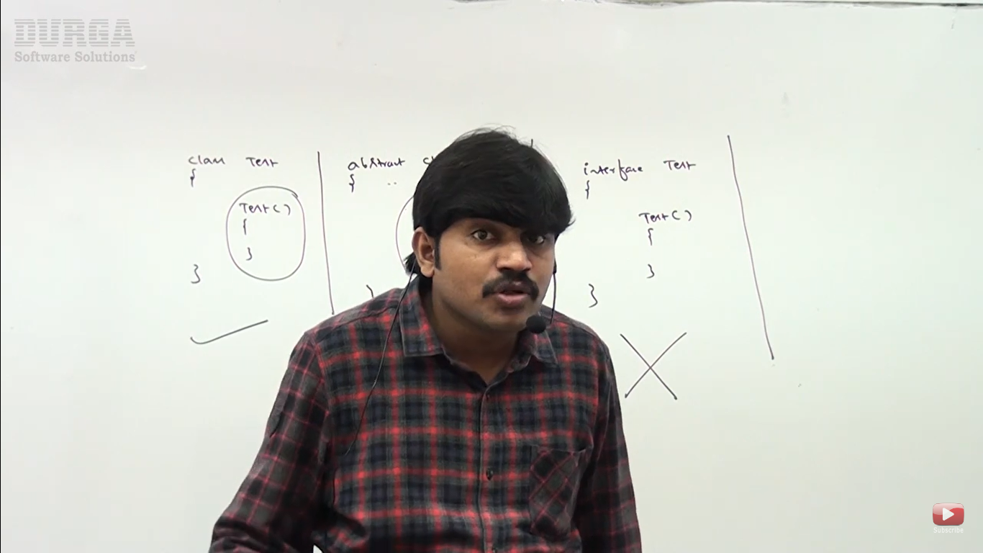

**Java recursive method and constructor calls**

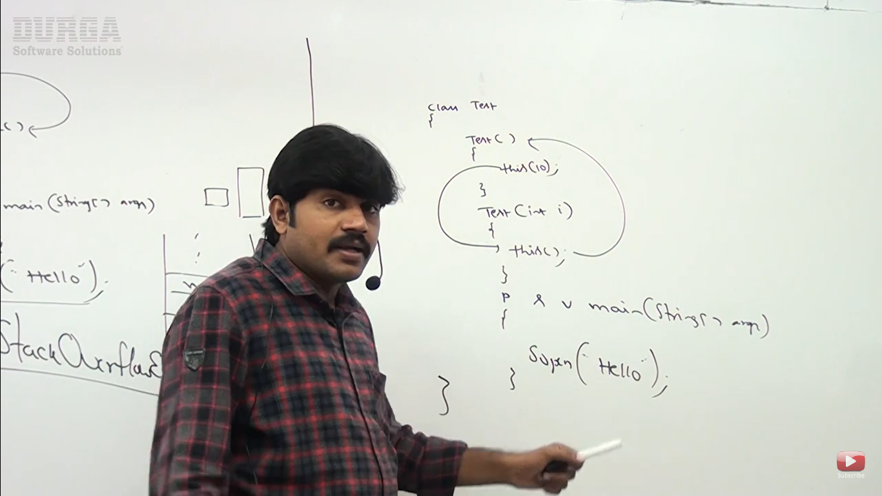

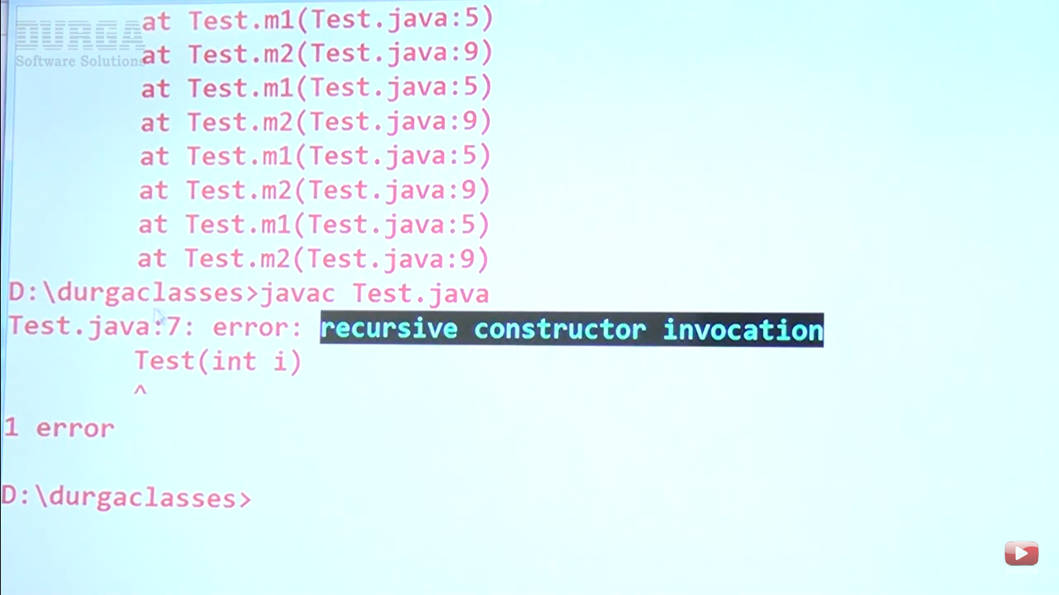

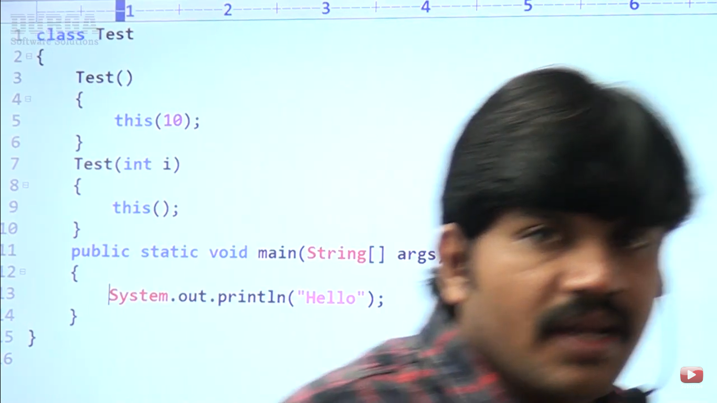

Related to constructor everything compiler is going to check.

**Parent and Child Constructor call by super()**

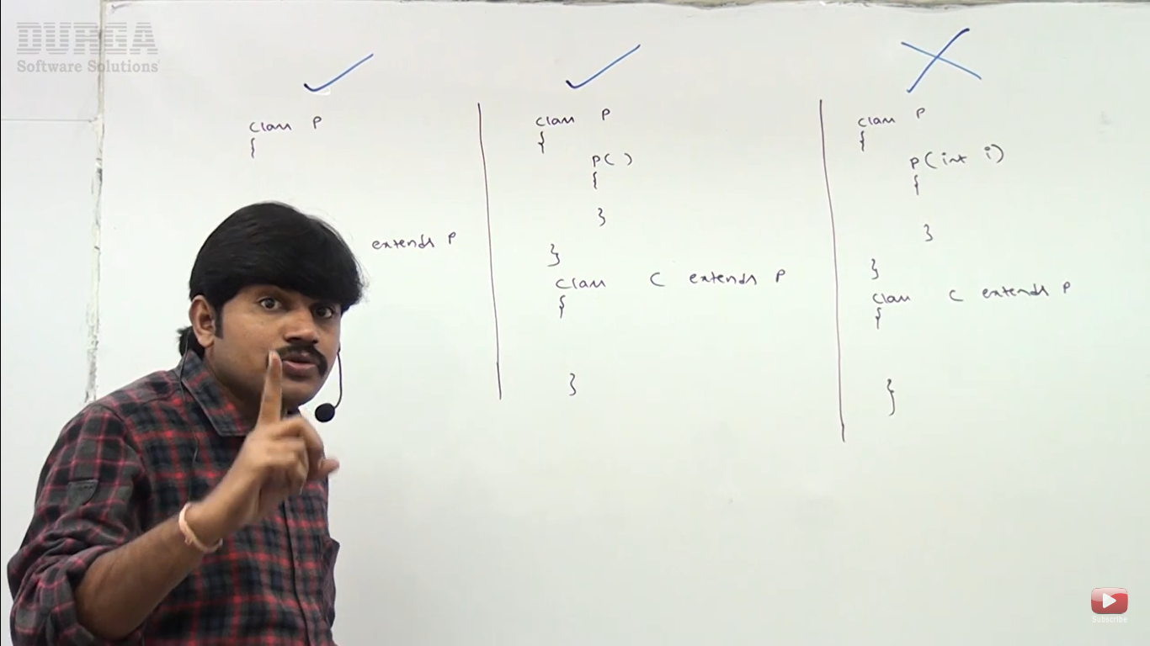

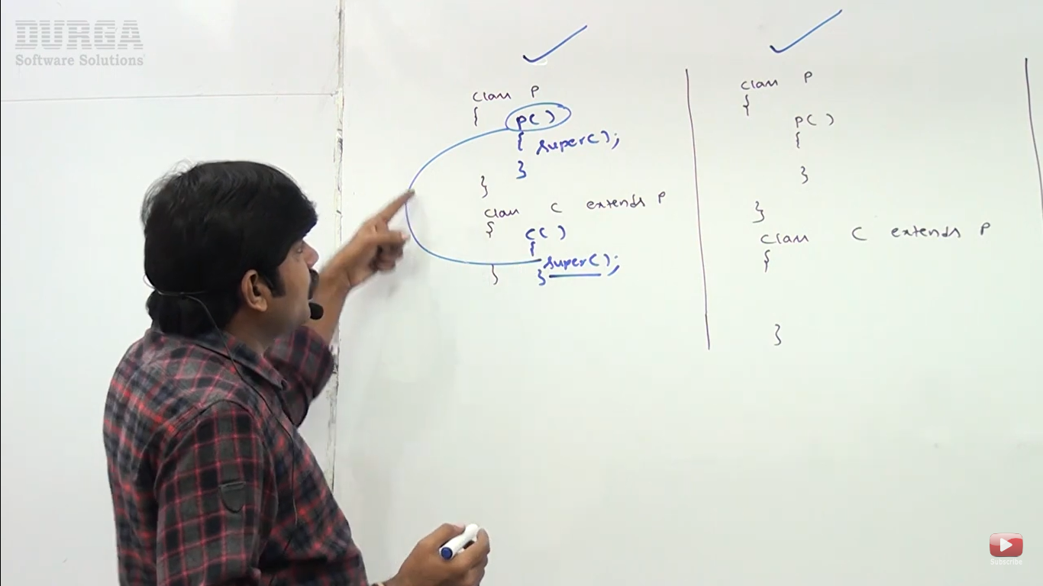

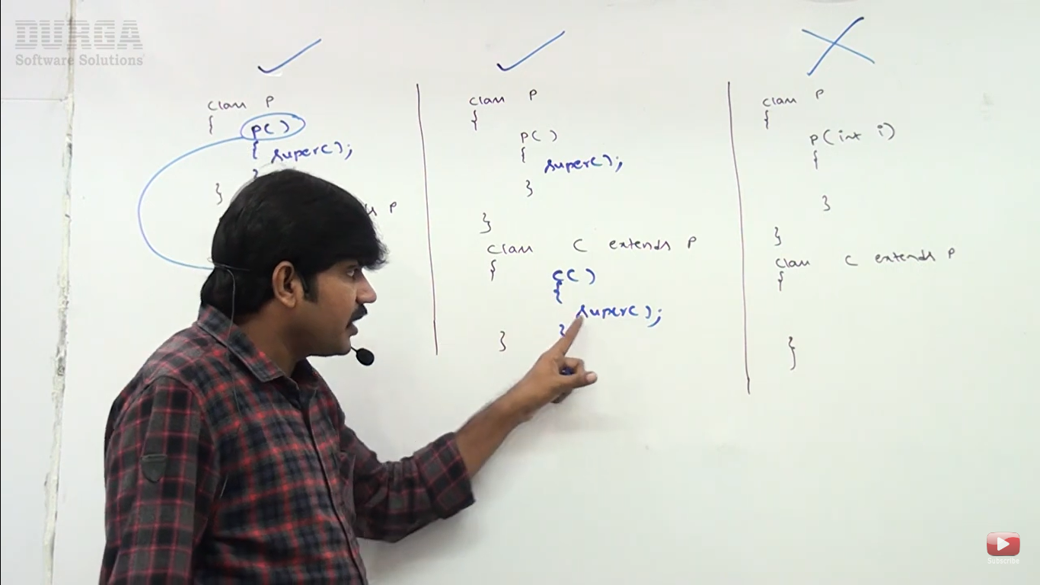

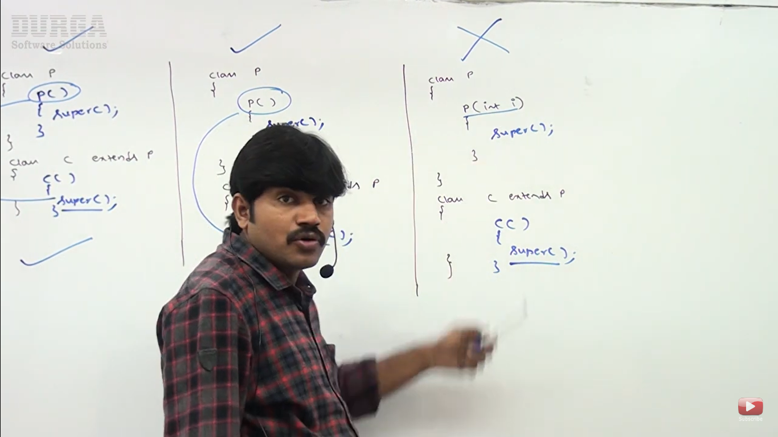

3rd case – Parent class doesn’t contain no–arg constructor.

